Vista Case Study – Part 1 – Building the Initial Data Model and Database

Introduction
Vista Wholesalers require an intranet-based system to manage the operation of their internal training courses and workshops.
The first part of the project is to develop the data model (based on the diagram below) and to build appropriate web services.
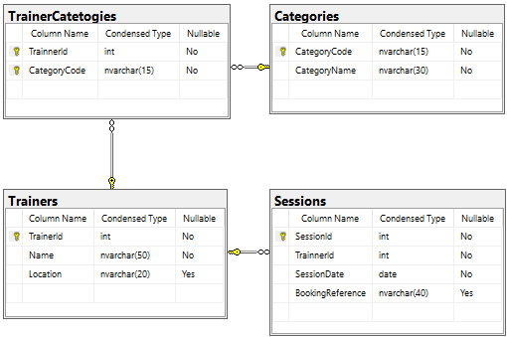
ERD for Trainer Database

Building the Data Model

Create a new ASP.NET Core Console App Project (with Solution)
- Open Visual Studio.
- Select Create a New Project.
- In the Create a New Project dialogue, select Console App (C# version) and click Next.
- In the Configure your new project dialog, set the following:
Project name: Visa.App
Location: <<Your Source>/Repo folder – e.g. C:\Users\a0001234\Source\Repos
Solution: Create new solution
Solution name: Vista
Ensure the dialog box looks like the following and click Next.

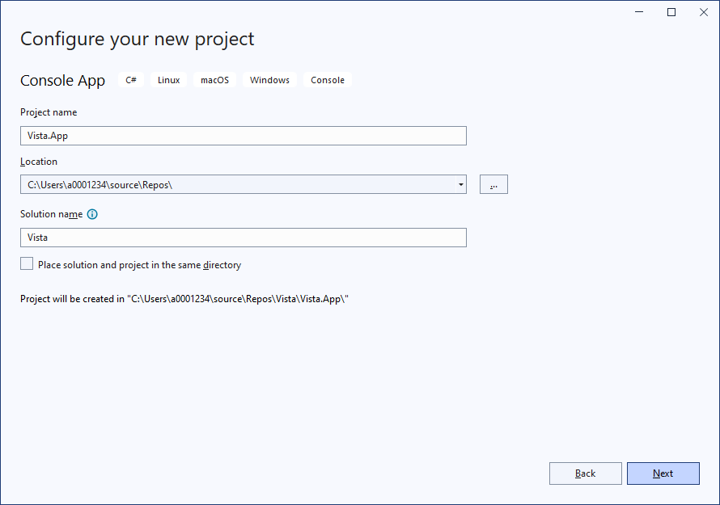
- On the Additional information dialog, ensure .NET 8.0 is selected and click Create.

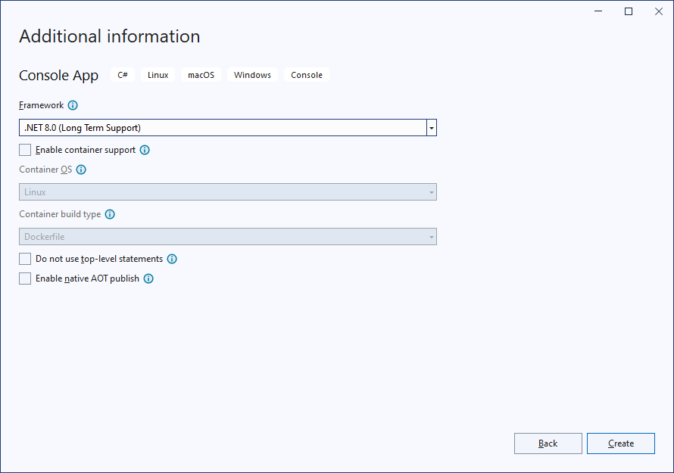
- Build and run the new project (Select Debug > Start Debugging). The following application should appear:
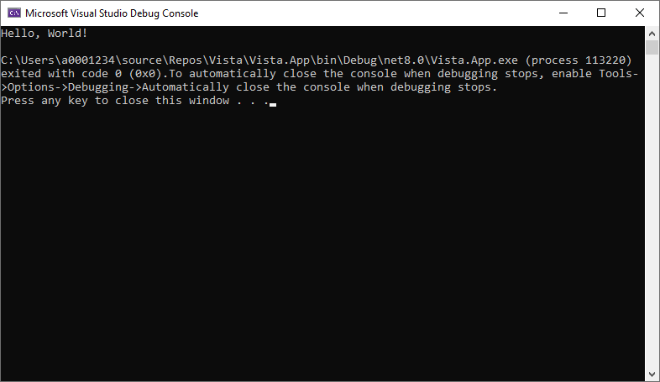

Create a Git Repository on GitHub
In this section, we will create a GitHub Repository for the solution.
- Ensure the Vista solution is open in Visual Studio.
- Select Git > Create Git Repository. The following dialog box will be displayed:
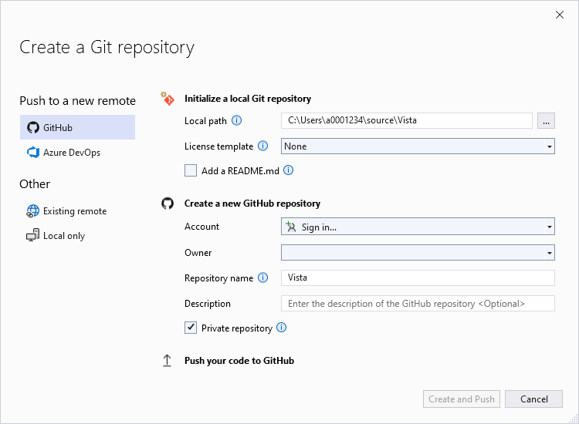
- Ensure that GitHub is selected in the side menu.
- If the Account shows, Sign In, select GitHub from the associated drop box and login via the browser window. Once the logon process is completed, the browser window will show:
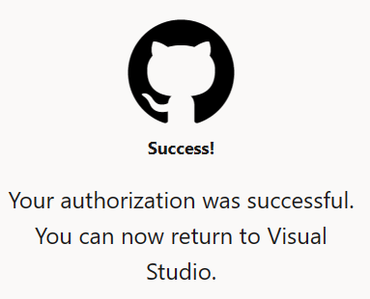
- Close the browser window and return to Visual Studio. The dialog box now to show:
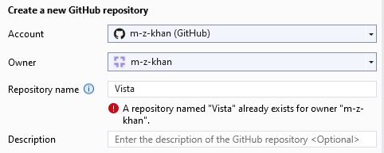
If you see a message to says the repository exists, you can select a different name or delete the existing repository on GitHub:
- In a browser, log in to your GitHub account (https://github.com).
- Select the Repository,
- On the repository page, select the Settings tab.
- On the Settings page, scroll to the bottom of the page and click on Delete this repository button.
- Follow the instructions to complete the process.
- Return to Visual Studio, and retype in the repository name to clear the repository exists message.
- Click Create and Push. You may be asked to save files. Once the repository is created the status bar will update to show:
Repository Name
Branch Name
Number of changed files since the last commit
Number of pending push/pull requests
Before finishing a coding session, ensure these numbers are set to zero by performing a commit and push (more details on this later in the tutorial).
- In a web browser, Log on to GitHub (https://github.com) and verify the vista project has been uploaded to the server.

Remember to commit and push to the server at key points at key points.

Add in Packages required for Entity Framework Core and SQLite
- Ensure the CarSalesApp solution is open in Visual Studio.
- Add in the packages required for the database functionality by
  - From the menu select Tools > NuGet Package Manager > Manage NuGet Packages for Solution… - the following tab should appear:

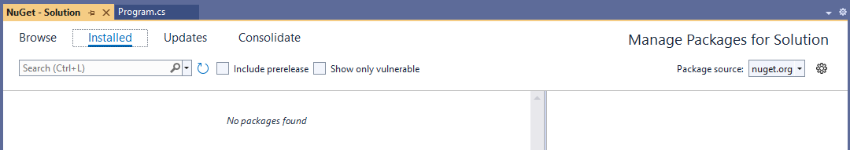

  - Select the Browser tab:
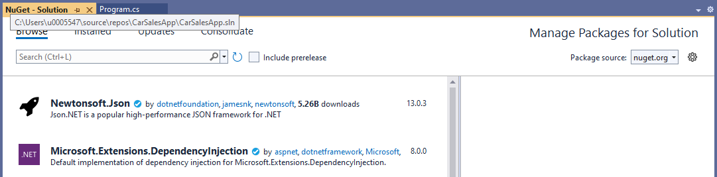

  - In the Search box, enter EntityFrameworkCore and browse the list to select Microsoft.EntityFrameworkCore (no prefixes). The following side panel will appear:

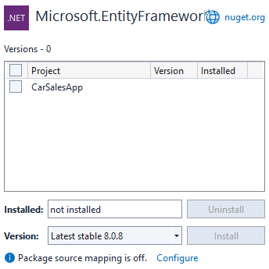

  - In the side panel:
    - Select CarSalesApp click (tick) the checkbox next to the project name
    - Change the Version number to the latest version of 8.0.x (currently 8.0.8).
  - Click Install. If a Preview Changes dialog appears, click on Apply.
  - The License Acceptance dialog will appear, click I Accept. The package(s) will be installed and the Output window updated.
  - Repeat the above process to add in the following packages:
- EntityFrameworkCore.SQLite (latest 8.0.x version)
- EntityFrameworkCore.Tools (latest 8.0.x version)
  - Close all the NuGet - Solution tab

Note: Packages can also be installed from Package Manager Console (Tools > NuGet Package Manager > Package Manager Console). In the Package Manager Console the following commands would achieve the same as the above:
Install-Package Microsoft.EntityFrameworkCore -Version 8.0.8
Install-Package Microsoft.EntityFrameworkCore.SQLite -Version 8.0.8
Install-Package Microsoft.EntityFrameworkCore.Tools -Version 8.0.8

- Run Build > Rebuild the solution and ensure there are no errors.

- Select Git > Commit or Stash… to open the Solution Explorer Git Changes panel.

- Create a commit by:

  - Entering a message: “Install EntityFramework Packages”
  - Clicking Commit All. If there any unsaved files, you will be you are prompted, select Save and commit.

- Select Git > Push to upload the latest changes from the local repo to the remote (GitHub) repo.
- Open your GitHub and check the new commit is present.

Add Basic Data Model Classes
- Ensure the Vista solution is open in Visual Studio.
- Create a new Data folder in the Vista.App project (right-click the project name [Vista.App] in the solution explorer and select Add > New Folder. Name the folder Data.
- In the data folder add a new class category by:
- Right-click the Data folder and select Add > Class…
- In the following dialog select Class and set the name to Category.cs.
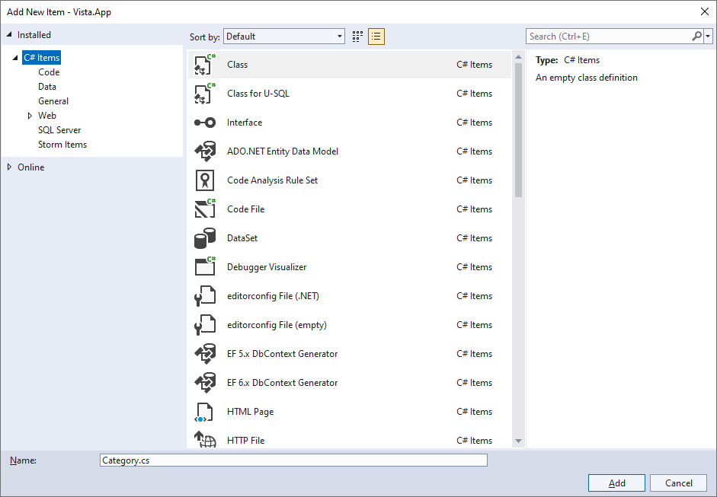
- Finally click Add

- The Category.cs class will appear. Update the code to the following:

using System.ComponentModel.DataAnnotations;

namespace Vista.App.Data
{
public class Category
{
[Key] // Since the key name (CategoryCode) does not include
// "Id", we have to use an annotation (could also
// specify this using FluitAPI)
[MaxLength(15)]
public required string CategoryCode { get; set; }

[MaxLength(30)]
public required string CategoryName { get; set; }

// Placeholder for List of Trainer Categories (many side of one-to-many)

}
}

Note:
- The above code introduces the required modifier. Microsoft definition: “The required modifier indicates that the field or property it's applied to must be initialized by an object initializer.

Any expression that initializes a new instance of the type must initialize all required members. The required modifier is available beginning with C# 11. The required modifier enables developers to create types where properties or fields must be properly initialized, yet still allow initialization using object initializers.”

Source: https://learn.microsoft.com/en-us/dotnet/csharp/language-reference/keywords/required
- [Required] annotation is NOT needed if the required modifier is used.
- This is NOT complete yet – we will add the related classes later.

- Add a new class called Trainer.cs to the data folder and update it to:

using System.ComponentModel.DataAnnotations;

namespace Vista.App.Data
{
public class Trainer
{
public int TrainerId { get; set; }

[MaxLength(50)]
public required string Name { get; set; }

[MaxLength(50)]
public string? Location { get; set; } // The question mark allow nulls

// Placeholder for List of Trainer Categories (many side of one-to-many)

// Placeholder for List of Sessions (many side of one-to-many)

}
}

Note: This is NOT complete yet –we will have to add in the related classes.

- Add a new class called TrainerCategory.cs to the data folder and update it to:
using System.ComponentModel.DataAnnotations;

namespace Vista.App.Data
{
public class TrainerCategory
{
// Has a composite (compound) key that will be defined TrainersDbConext

[Required]
public int TrainerId { get; set; }

[MaxLength(15)]
public required string CategoryCode { get; set; }

// Placeholder a navigation property to Trainer (one side of one-to-many)

// See TrainersDbConext for Foreign Key (Fluent API) definition
// Placeholder for a navigation property to Category (one side of one-to-many)
}
}

Note: This is NOT complete yet –we will have to add in the related classes and define the composite (compound) key.

- Add a new class called Session.cs to the data folder and update it to:
using System.ComponentModel.DataAnnotations;

namespace Vista.App.Data
{
public class Session
{
public int SessionId { get; set; }

public int TrainerId { get; set; }

[Required]
[DataType(DataType.Date)]
public DateTime SessionDate { get; set; }

[MaxLength(40)]
public string? BookingReference { get; set; } // Allow nulls

// Placeholder for a navigation property to trainer (one side of one-to-many)

}
}

Note: This is NOT complete yet –we will have to add in the related classes.

- We now have all the data classes:

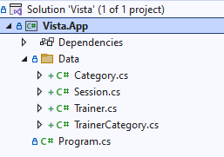

Run Build > Rebuild the solution and ensure there are no errors.

Add Relationships
- Ensure the Vista solution is open in Visual Studio.

- Update Trainer.cs to let the framework know that Trainer is related to TrainerCategory by replacing:

// Placeholder for List of Trainer Categories (many side of one-to-many)
With:
public List<TrainerCategory>? TrainerCategories { get; set; }

Note:
- The question mark (?) mark at the end of List<TrainerCategory> indicates that TrainerCategories can be null – we can have a category entry without any trainers associated with it.
- The standard conversion of making the class singular (TrainerCategory) and instance/object name plural (TrainerCategories) has been followed.

- Update Trainer.cs to let the framework know that Trainer is related to Session by replacing:
// Placeholder for List of Sessions (many side of one-to-many)
With:
public List<Session>? Sessions { get; set; }

- Update Category.cs to let the framework know that Category is related to TrainerCategory by replacing:
// Placeholder for List of Trainer Categories (many side of one-to-many)
With:
public List<TrainerCategory>? TrainerCategories { get; set; }

- Update TrainerCategory.cs to let the framework know that TrainerCategory is related to Trainer by replacing:
// Placeholder a navigation property to Trainer (one side of one-to-many)
With:
public Trainer? Trainer { get; set; }

- Update TrainerCategory.cs to let the framework know that TrainerCategory is related to Category by replacing:
// Placeholder for a navigation property to Category (one side of one-to-many)
With:
public Category? Category { get; set; }

Note: This is NOT complete yet – we will still need to define the composite (compound) key.

- Update Session.cs to let the framework know that Session is related to Trainer by replacing:
// Placeholder for a navigation property to trainer (one side of one-to-many)
With:
public Trainer? Trainer { get; set; }

- Run Build > Rebuild the solution and ensure there are no errors.

Create the database context
- Ensure the Vista solution is open in Visual Studio.
- Add a new class called TrainersDbContext.cs to the data folder and update it to:

using Microsoft.EntityFrameworkCore;

namespace Vista.App.Data
{
public class TrainersDbContext : DbContext
{
// Notes
// - DbSet defines the database table.
// - the class name is defined as part of the data model
// - the instance/object name is normally plural
// - by default, the instance name will become the table name
public DbSet<Category> Categories { get; set; }

public DbSet<Trainer> Trainers { get; set; }

public DbSet<TrainerCategory> TrainerCategories { get; set; }

public DbSet<Session> Sessions { get; set; }

private string DbPath { get; set; } = string.Empty;

// Constructor to set-up the database path & name
public TrainersDbContext()
{
var folder = Environment.SpecialFolder.MyDocuments;
var path = Environment.GetFolderPath(folder);
DbPath = Path.Join(path, "vista.trainers.db");
}

// OnConfiguring to specify that the SQLite database engine will be used
protected override void OnConfiguring(DbContextOptionsBuilder optionsBuilder)
{
base.OnConfiguring(optionsBuilder);
optionsBuilder.UseSqlite($"Data Source={DbPath}");
}

protected override void OnModelCreating(ModelBuilder builder)
{
base.OnModelCreating(builder);

// Composite (Compound) Key
builder.Entity<TrainerCategory>()
.HasKey(ts => new { ts.TrainerId, ts.CategoryCode });

// EF Core can work out most relationships from the navigation properties
// One "Category" to many "TrainerCategories" needs to be defined because it does
// NOT have a “conventional” primary column name (i.e. CategoryId) and is based
// on a Composite key
builder.Entity<Category>()
.HasMany(c => c.TrainerCategories)
.WithOne(tr => tr.Category)
.HasForeignKey(tr => tr.CategoryCode)
.OnDelete(DeleteBehavior.Restrict);
// The OnDelete prevents categories from being deleted if there are
// corresponding entities within the TrainerCategories

// Manually define the Trainer to TrainerCategories relationship to
// enforce the delete rule.
builder.Entity<Trainer>()
.HasMany(c => c.TrainerCategories)
.WithOne(tr => tr.Trainer)
.OnDelete(DeleteBehavior.Restrict);

// Seed/Test data to be added here

}

}
}

- Run Build > Rebuild the solution and ensure there are no errors.
- Update TrainersDbContext.cs to replace:
// Seed/Test data to be added here

With:

// Insert Seed/Test Data
builder.Entity<Category>().HasData(
new Category { CategoryCode = "IT", CategoryName = "Information Technology" },
new Category { CategoryCode = "HS", CategoryName = "Health and Safety" },
new Category { CategoryCode = "LM", CategoryName = "Leadership and Management" },
new Category { CategoryCode = "ED", CategoryName = "Equality and Diversity" },
new Category { CategoryCode = "MAR", CategoryName = "Marketing" }
);

builder.Entity<Trainer>().HasData(
new Trainer { TrainerId = 1, Name = "Palmer Patel", Location = "Middlesbrough" },
new Trainer { TrainerId = 2, Name = "Cater Moon", Location = "Stockton-on-Tees" },
new Trainer { TrainerId = 3, Name = "Alex Dickerson", Location = "Middlesbrough" },
new Trainer { TrainerId = 4, Name = "Sally Johnson", Location = "Stockton-on-Tees" }
);

builder.Entity<TrainerCategory>().HasData(
new TrainerCategory { TrainerId = 1, CategoryCode = "IT" },
new TrainerCategory { TrainerId = 1, CategoryCode = "ED" },
new TrainerCategory { TrainerId = 2, CategoryCode = "LM" },
new TrainerCategory { TrainerId = 2, CategoryCode = "HS" },
new TrainerCategory { TrainerId = 2, CategoryCode = "ED" },
new TrainerCategory { TrainerId = 3, CategoryCode = "IT" },
new TrainerCategory { TrainerId = 3, CategoryCode = "LM" }
);

builder.Entity<Session>().HasData(
new Session { SessionId = 1, TrainerId = 1, SessionDate = new DateTime(2023, 1, 10) },
new Session { SessionId = 2, TrainerId = 1, SessionDate = new DateTime(2023, 1, 11) },
new Session { SessionId = 3, TrainerId = 1, SessionDate = new DateTime(2023, 1, 12) },
new Session { SessionId = 4, TrainerId = 1, SessionDate = new DateTime(2023, 1, 13) },
new Session { SessionId = 5, TrainerId = 1, SessionDate = new DateTime(2023, 1, 14),
BookingReference = "TST-99" },
new Session { SessionId = 6, TrainerId = 1, SessionDate = new DateTime(2023, 1, 17) },
new Session { SessionId = 7, TrainerId = 1, SessionDate = new DateTime(2023, 1, 18) },
new Session { SessionId = 8, TrainerId = 1, SessionDate = new DateTime(2023, 1, 19) },
new Session { SessionId = 9, TrainerId = 1, SessionDate = new DateTime(2023, 1, 20) },
new Session { SessionId = 10, TrainerId = 1, SessionDate = new DateTime(2023, 1, 21) },

new Session { SessionId = 11, TrainerId = 2, SessionDate = new DateTime(2023, 1, 10) },
new Session { SessionId = 12, TrainerId = 2, SessionDate = new DateTime(2023, 1, 11) },
new Session { SessionId = 13, TrainerId = 2, SessionDate = new DateTime(2023, 1, 12) },
new Session { SessionId = 14, TrainerId = 2, SessionDate = new DateTime(2023, 1, 13) },
new Session { SessionId = 15, TrainerId = 2, SessionDate = new DateTime(2023, 1, 14) },
new Session { SessionId = 16, TrainerId = 2, SessionDate = new DateTime(2023, 1, 17),
BookingReference = "TST-98" },
new Session { SessionId = 17, TrainerId = 2, SessionDate = new DateTime(2023, 1, 18),
BookingReference = "TST-97" },
new Session { SessionId = 18, TrainerId = 2, SessionDate = new DateTime(2023, 1, 19) },
new Session { SessionId = 19, TrainerId = 2, SessionDate = new DateTime(2023, 1, 20) },
new Session { SessionId = 20, TrainerId = 2, SessionDate = new DateTime(2023, 1, 21) },

new Session { SessionId = 21, TrainerId = 3, SessionDate = new DateTime(2023, 1, 10) },
new Session { SessionId = 22, TrainerId = 3, SessionDate = new DateTime(2023, 1, 11) },
new Session { SessionId = 23, TrainerId = 3, SessionDate = new DateTime(2023, 1, 12) },
new Session { SessionId = 24, TrainerId = 3, SessionDate = new DateTime(2023, 1, 13),
BookingReference = "TST-96" },
new Session { SessionId = 25, TrainerId = 3, SessionDate = new DateTime(2023, 1, 14) },
new Session { SessionId = 26, TrainerId = 3, SessionDate = new DateTime(2023, 1, 17) },
new Session { SessionId = 27, TrainerId = 3, SessionDate = new DateTime(2023, 1, 18) },
new Session { SessionId = 28, TrainerId = 3, SessionDate = new DateTime(2023, 1, 19) },
new Session { SessionId = 29, TrainerId = 3, SessionDate = new DateTime(2023, 1, 20) },
new Session { SessionId = 30, TrainerId = 3, SessionDate = new DateTime(2023, 1, 21),
BookingReference = "TST-94" },

new Session { SessionId = 31, TrainerId = 4, SessionDate = new DateTime(2023, 1, 11) },
new Session { SessionId = 32, TrainerId = 4, SessionDate = new DateTime(2023, 1, 12) },
new Session { SessionId = 33, TrainerId = 4, SessionDate = new DateTime(2023, 1, 13), BookingReference = "TST-95" },
new Session { SessionId = 34, TrainerId = 4, SessionDate = new DateTime(2023, 1, 18) },
new Session { SessionId = 35, TrainerId = 4, SessionDate = new DateTime(2023, 1, 19) },
new Session { SessionId = 36, TrainerId = 4, SessionDate = new DateTime(2023, 1, 20) }

);

- Run Build > Rebuild the solution and ensure there are no errors.

Add first database migration and Create Database
- Ensure the Vista solution is open in Visual Studio.
- Ensure Vista.App is selected as the startup project (in solution explorer, right-click the project name and select Set as startup project).
- Open Package Manager Console (Tools > NuGet Package Manager > Package Manager Console):
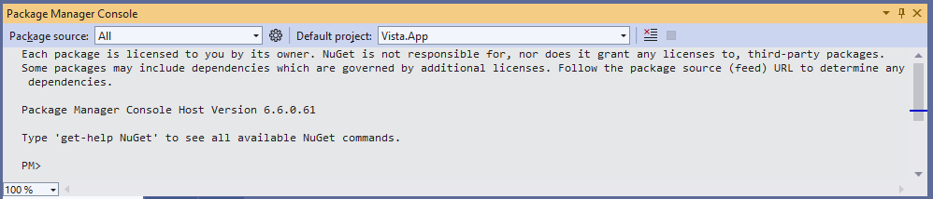
- Ensure the Default project is set to Vista.App.
- In the Package Manager Console type in the following command:
Add-Migration InitialCreate -OutputDir Data/Migrations
Ensure there are no errors (you should see To undo this action, use Remove-Migration.). The solution explorer will update to show the migration files, once expanded it should look like the following screenshot:

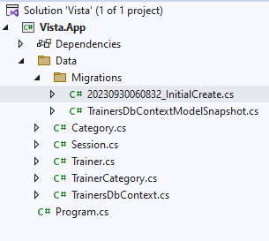

The …_InitialCreate.cs file contains the C# code to build the database.

Every time a change is made to the data model or seed data a new migration should be added with an appropriate name.

- If you have worked through this tutorial before, please ensure the vista.trainers.db database file is deleted from your My Documents folder (U:\ for the machines in the IT Labs).
- In the Package Manager Console type in the following command:
Update-Database
You should get a confirmation similar to the following:

Build started...
Build succeeded.
Applying migration ' 20231005060832_InitialCreate '.
Done.

At this point, the database (vista.trainers.db) has been created in the My Documents folder (U:\ for the machines in the IT Labs).

- Use DB Browser for SQLite (or a similar tool) to inspect the database. Once the database is open in DB Browser you should see:
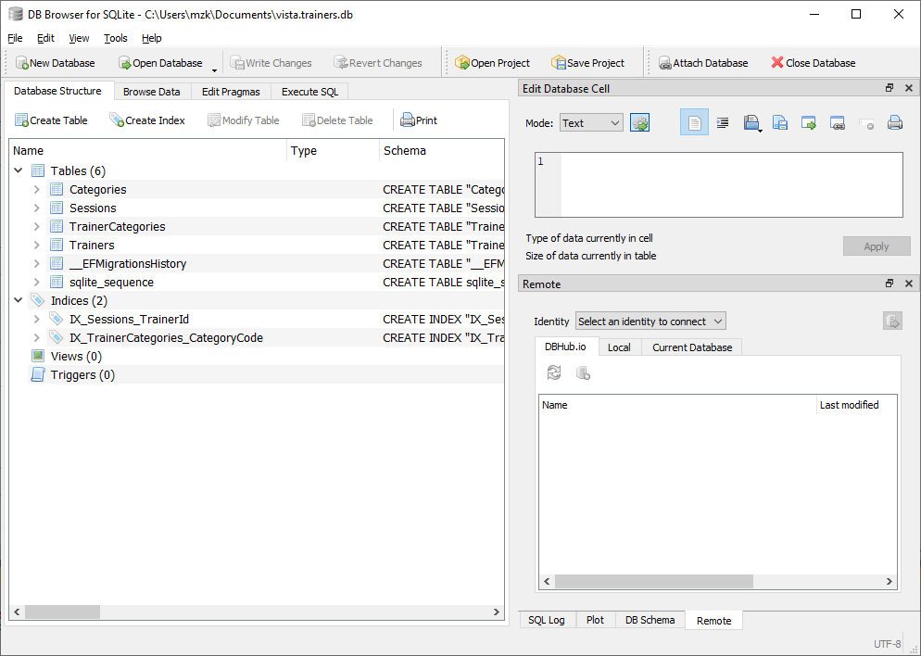
- Select the Browse Data tab, to inspect the data:

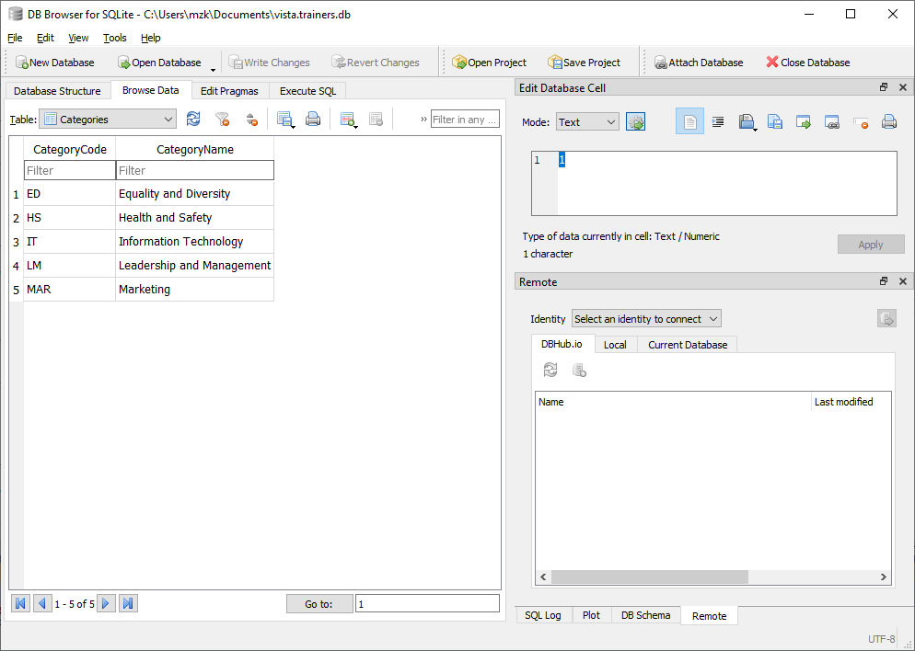

- Close the database (File > Close Database) Select the Browse Data tab, to inspect the data:
S

Testing the Database
In this section, we will update the main program (in program.cs) to run some database queries to test our solution.

List the Categories
- Ensure the Vista solution is open in Visual Studio.
- From the Solution Explorer, Open program.cs, you should see:
// See https://aka.ms/new-console-template for more information
Console.WriteLine("Hello, World!");

- Replace the above code with:

using Vista.App.Data; // Import the database classes

var trainerDbContext = new TrainersDbContext(); // Create database context

ListCateogies(trainerDbContext);

// Method to List Categories from the database
static void ListCateogies(TrainersDbContext dbContext)
{
// Load list of categories from the database
var catogoryList = dbContext.Categories.ToList();

Console.WriteLine("Category List\n");

// Display list of categories from the memory object (categoryList)
foreach (var cat in catogoryList)
{
Console.WriteLine($"{cat.CategoryCode} {cat.CategoryName}");
}
Console.WriteLine();
}

- Build and run the new project (Select Debug > Start Debugging). The following application should appear:

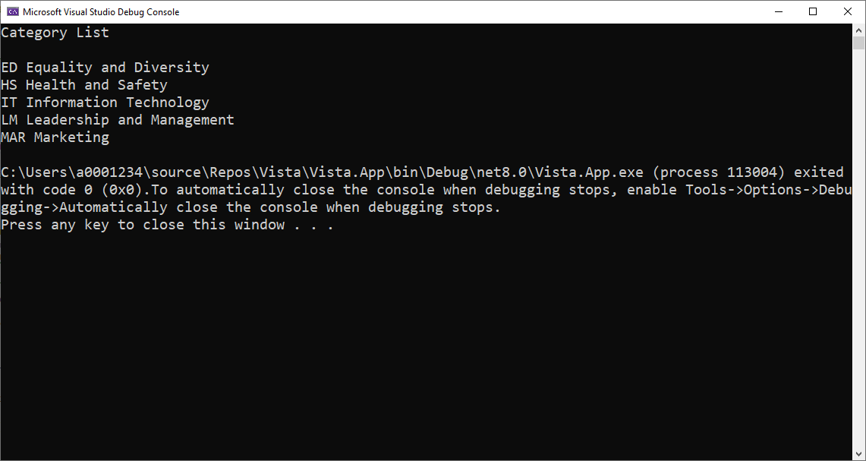

- Press any key to close the window.

List the Trainers
- Ensure the Vista solution is open in Visual Studio.
- From the Solution Explorer, Open program.cs
- At the end of the program.cs file, add the following method:

// Method to List trainers from the database
static void ListTrainers(TrainersDbContext dbContext)
{
// Load list of categories from the database
var trainerList = dbContext.Trainers.ToList();

Console.WriteLine("Trainer List\n");

// Display list of categories from the memory object (trainerList)
foreach (var t in trainerList)
{
Console.WriteLine($"{t.TrainerId} {t.Name}");
}
Console.WriteLine();
}

- Edit the top of the program.cs file, to add in the highlighted line:
using Microsoft.EntityFrameworkCore;
using Vista.App.Data; // Import the database classes

var trainerDbContext = new TrainersDbContext(); // Create database context

ListCateogies(trainerDbContext);
ListTrainers(trainerDbContext);

- Build and run the new project (Select Debug > Start Debugging). The following application should appear:

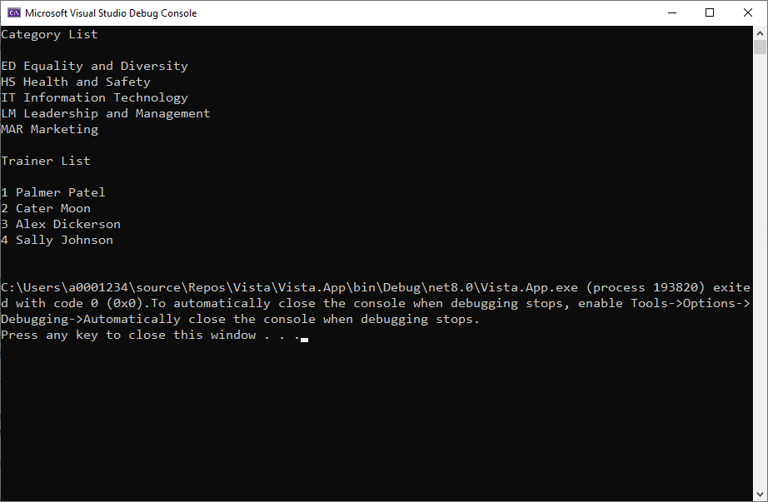

- Press any key to close the window.

Next steps

Remember to back up your code.

Once the data model and database are created, we can start to build services. For simple CRUD (Create Read, Update and Delete) operations.

